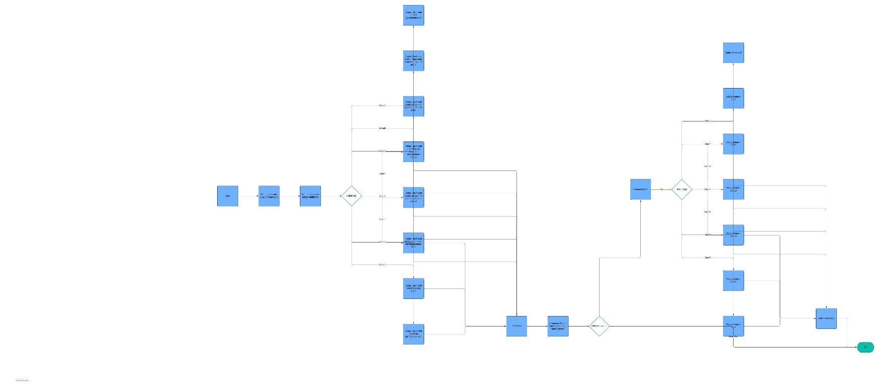Question 2

1. Begin
2. Prompt user to enter a day of creation (1-7)
3. Parse the input to an integer variable day
4. Switch (day)

Case 1:

Display "Day 1: God created light.\nGenesis 1:3"

Break

Case 2:

Display "Day 2: God created the sky.\nGenesis 1:6-8"

Break

Case 3:

Display "Day 3: God created dry land and vegetation.\nGenesis 1:9-13"

Break

Case 4:

Display "Day 4: God created the sun, moon, and stars.\nGenesis 1:14-19"

Break

Case 5:

Display "Day 5: God created sea creatures and birds.\nGenesis 1:20-23"

Break

Case 6:

Display "Day 6: God created animals and mankind.\nGenesis 1:24-31"

Break

Case 7:

Display "Day 7: God rested.\nGenesis 2:1-3"

Break

Default:

Display "Invalid day entered. Please enter a number between 1 and 7."

Break

Prompt user "Do you want to see the verse again? (yes/no)"

Get user response

If response is "yes"

Switch (day)

Case 1:

Display "Genesis 1:3"

Break

Case 2:

Display "Genesis 1:6-8"

Break

Case 3:

Display "Genesis 1:9-13"

Break

Case 4:

Display "Genesis 1:14-19"

Break

Case 5:

Display "Genesis 1:20-23"

Break

Case 6:

Display "Genesis 1:24-31"

Break

Case 7:

Display "Genesis 2:1-3"

Break

8. End